January 17, 2025

Dear Landowner,

Box Elder County has received a proposal to create an Agricultural Protection Area in the vicinity of a property that is listed in your name. Please be aware of an upcoming public hearing (notice is set forth below).

**NOTICE OF PUBLIC HEARING**

NOTICE IS HEREBY GIVEN that a public hearing has been scheduled on February 12, 2025 at 5:00 p.m. or as soon as possible thereafter, to receive public input regarding a proposal to create an Agricultural Protection Area in the West Corinne Area of unincorporated Box Elder County. The public hearing will be held in the Commission Chambers at the Box Elder County Courthouse 1 S Main Street, Brigham City, Utah 84302. All interested parties are invited to attend.

*Please see attached map showing the location of the proposed Agricultural Protection area.

*Box Elder County Planning Commission and the Agricultural Protection Board have both reviewed the proposal for creating an agricultural protection area and have forwarded their recommendations for approval.

Sincerely,

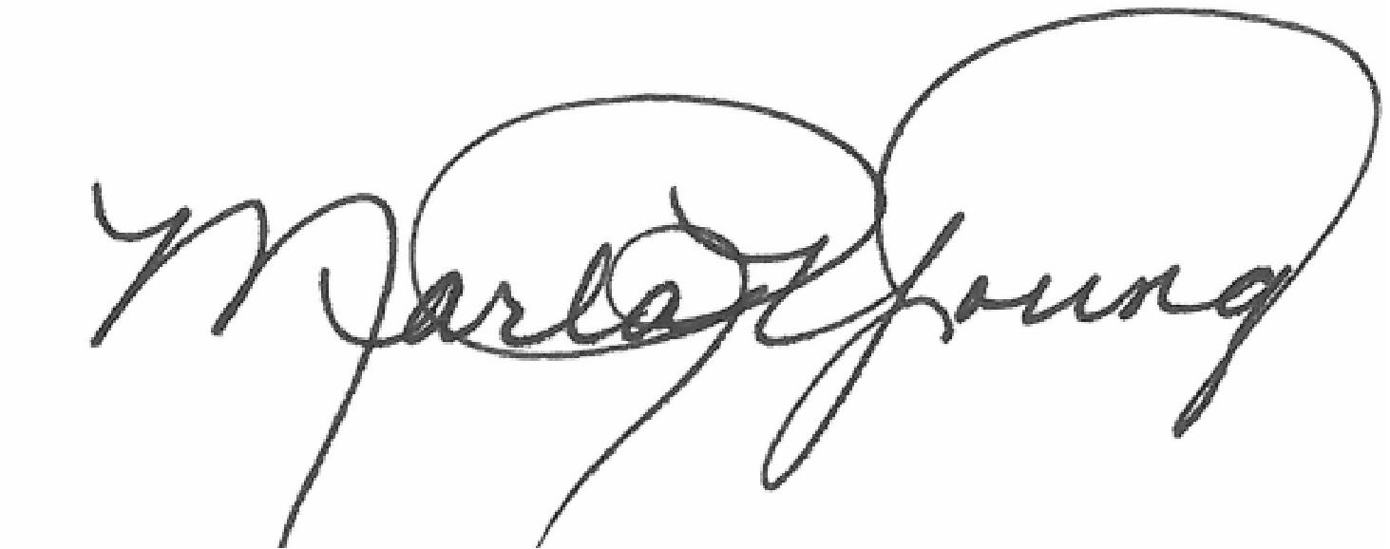

Marla R. Young

Box Elder County Clerk